Lab 07: Access resource secrets more securely across services

## **Microsoft Azure user interface**

Given the dynamic nature of Microsoft cloud tools, you might experience Azure UI changes that occur after this training content's development. As a result, the lab instructions and lab steps might not align correctly.

Microsoft updates this training course when the community brings needed changes to our attention. However, because cloud updates occur frequently, you might encounter UI changes before this training content updates. **If this occurs, adapt to the changes, and then work through them in the labs as needed.**

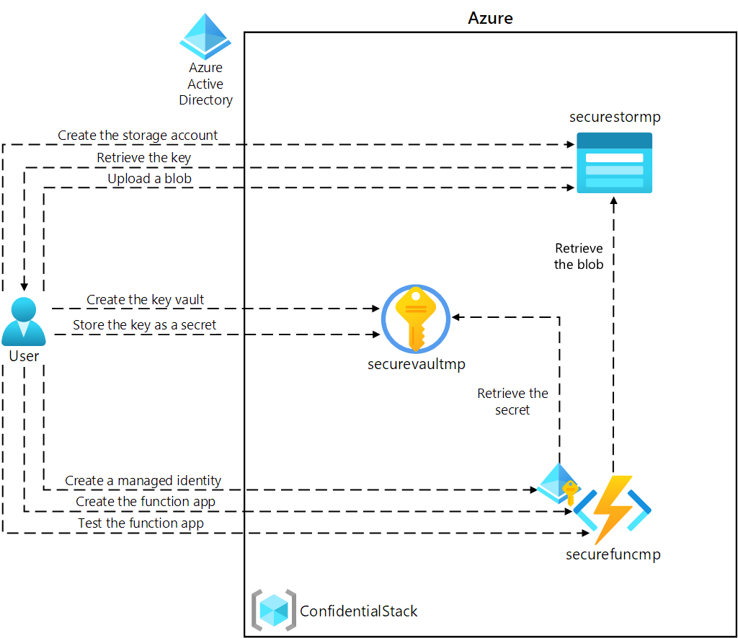

Create user

#### **Task 2: Create a Storage account**

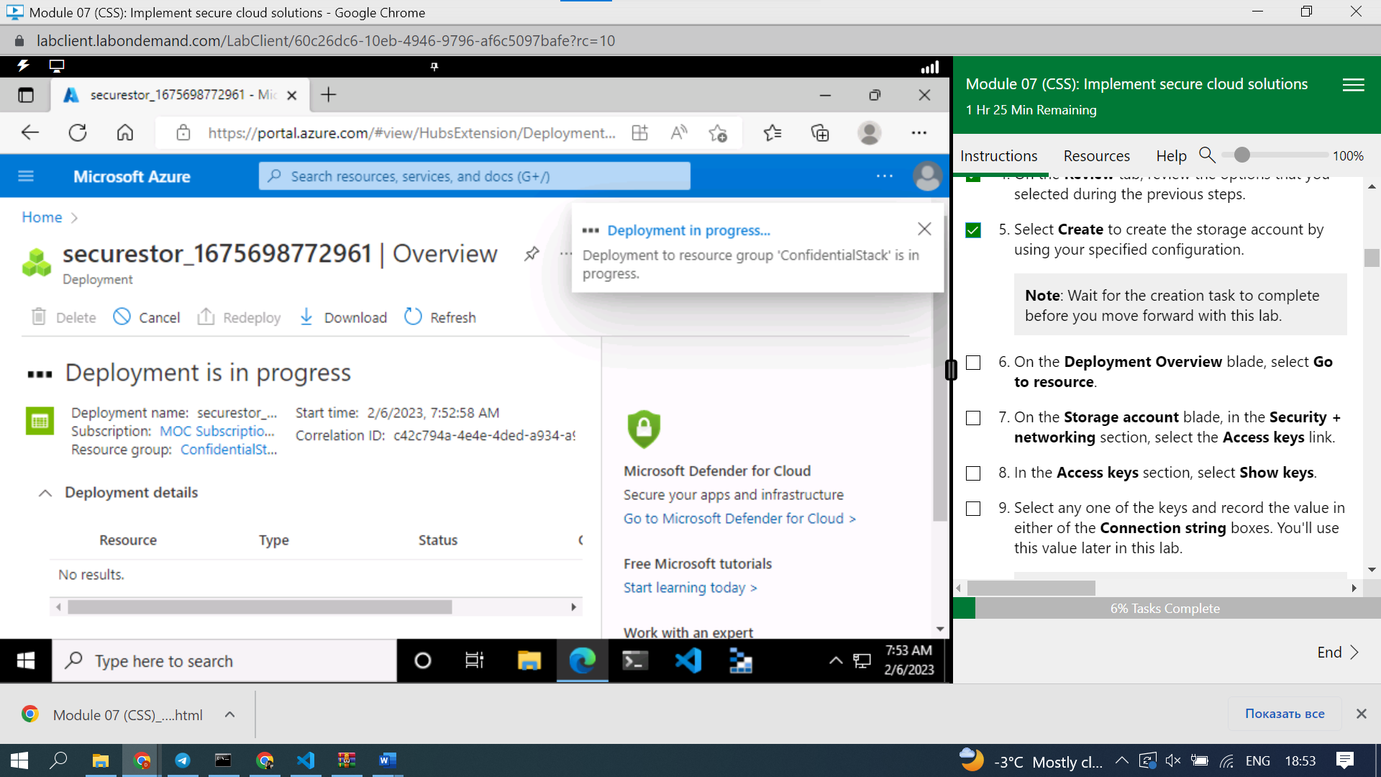

#### **Task 3: Create an Azure Key Vault**

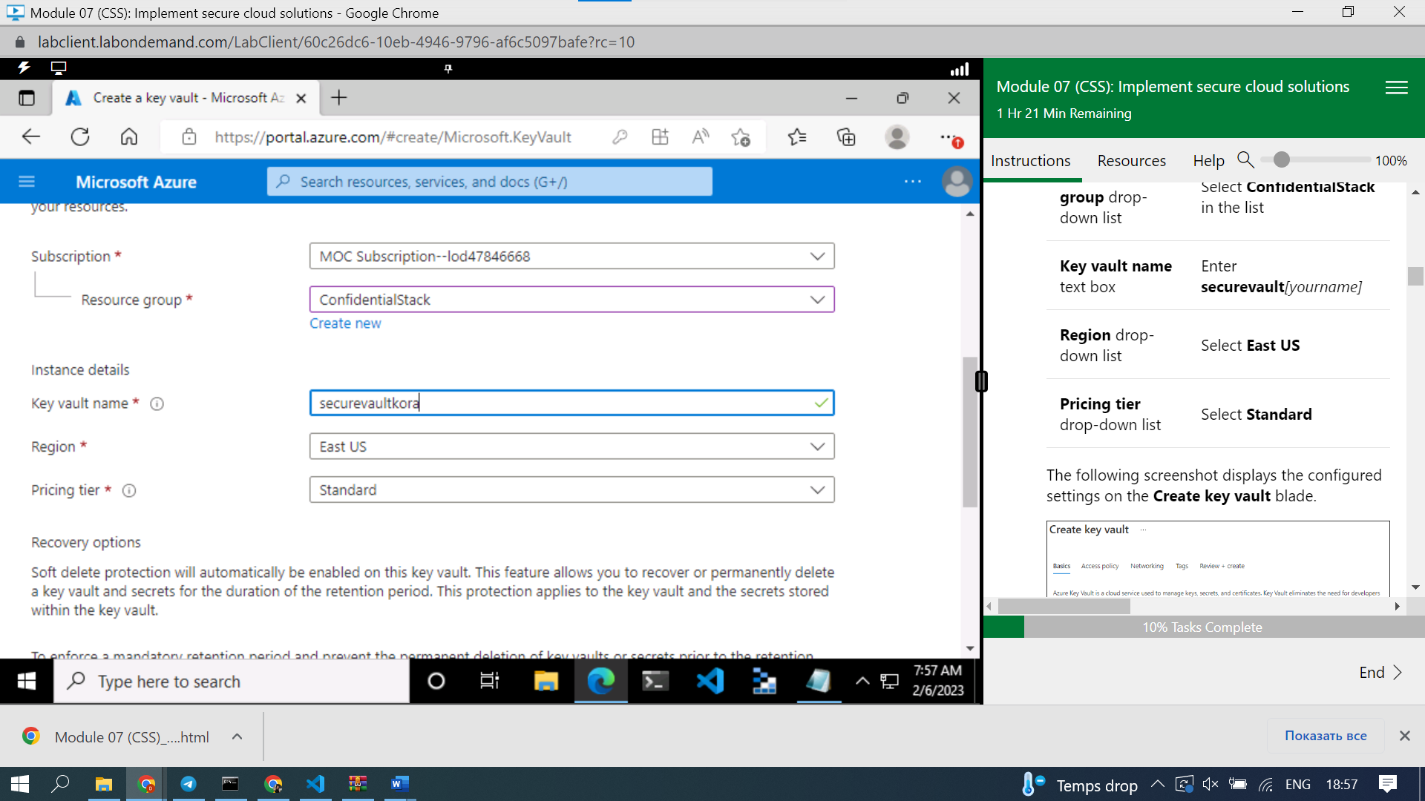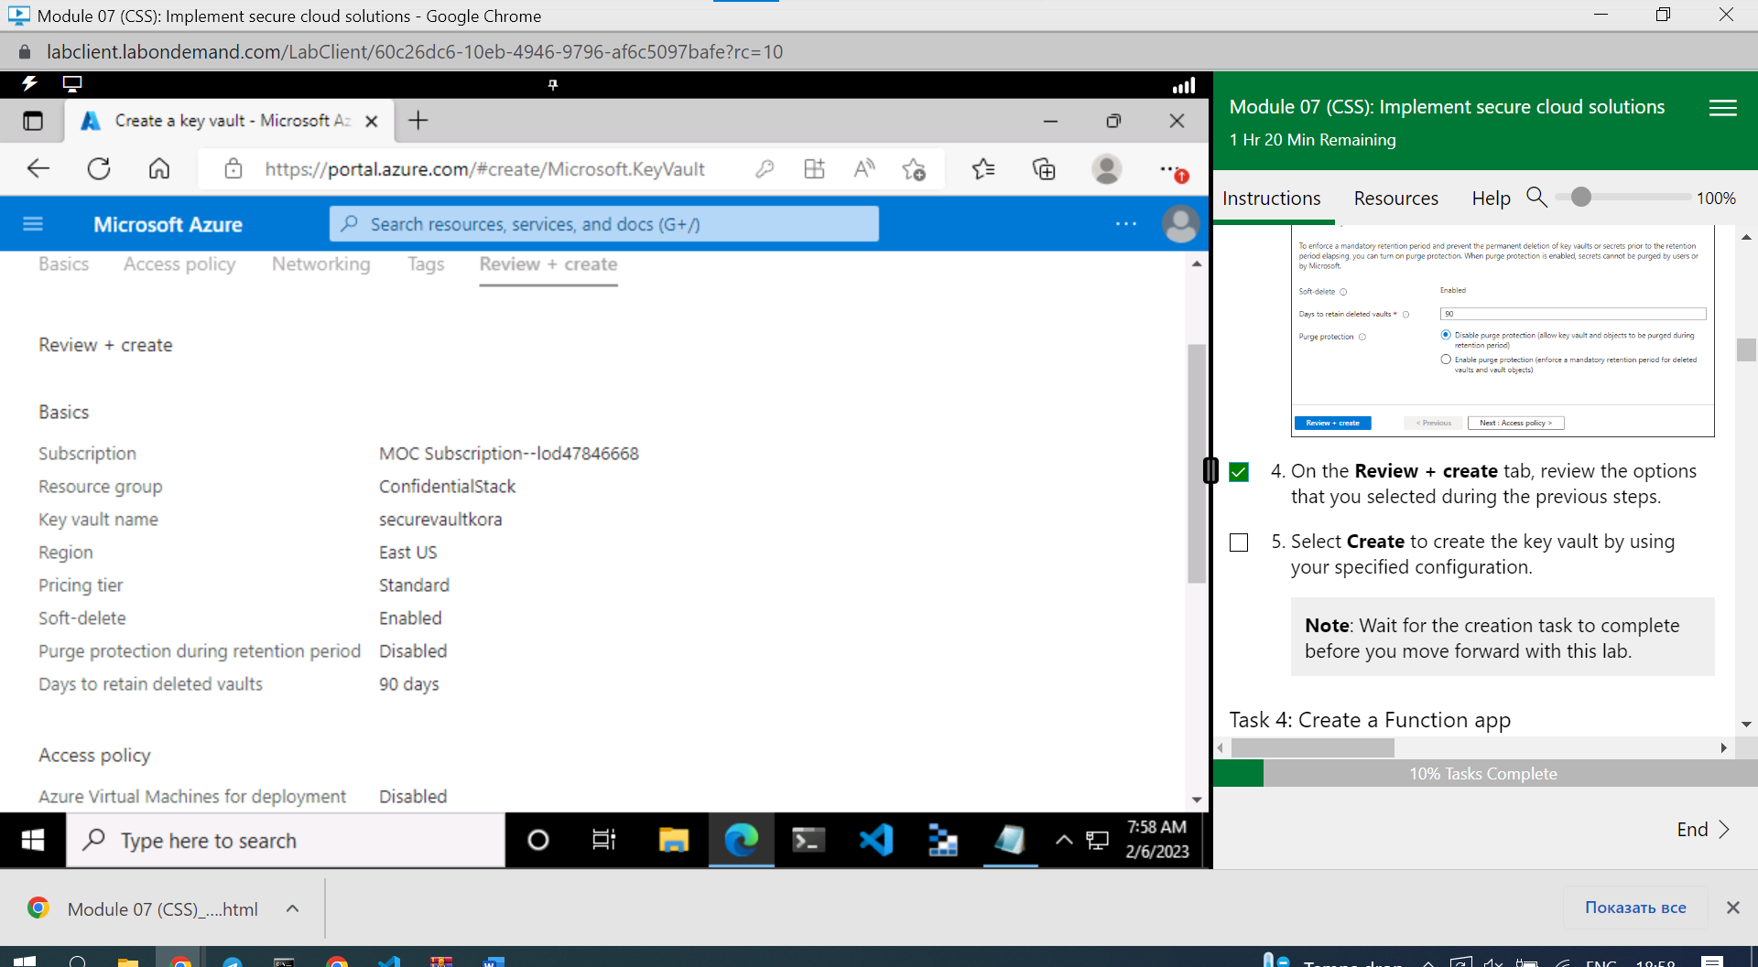

#### **Task 4: Create a Function app**

#### **Review**

In this exercise, you created all the resources that you'll use in this lab.

### **Exercise 2: Configure secrets and identities**

#### **Task 1: Configure a system-assigned managed service identity**

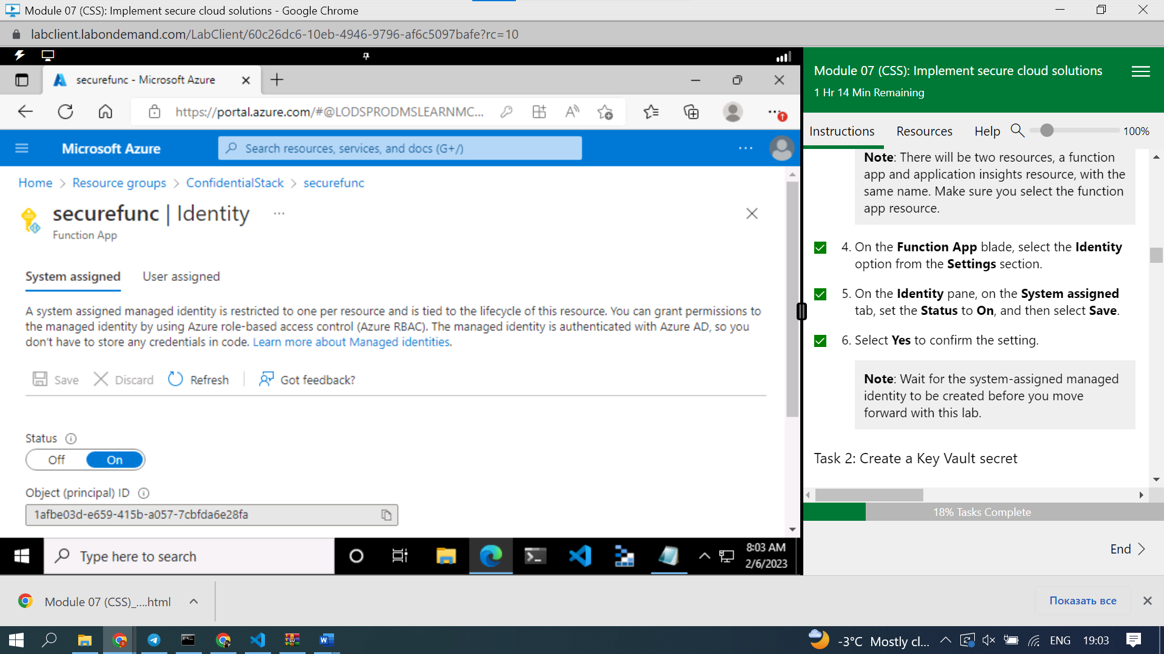

#### **Task 2: Create a Key Vault secret**

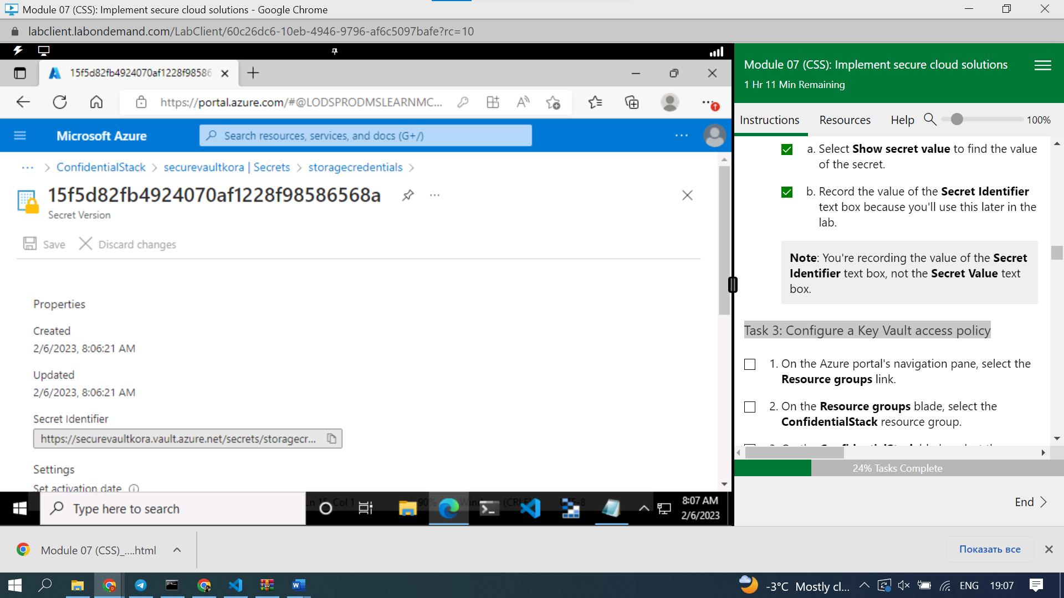

#### **Task 3: Configure a Key Vault access policy**

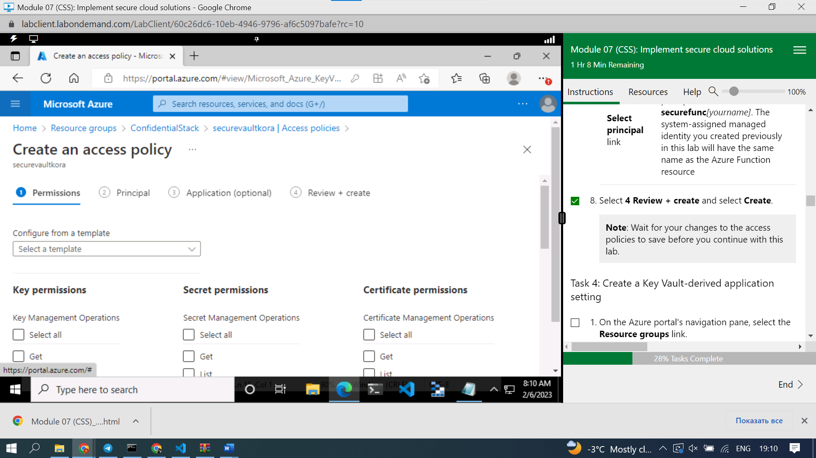

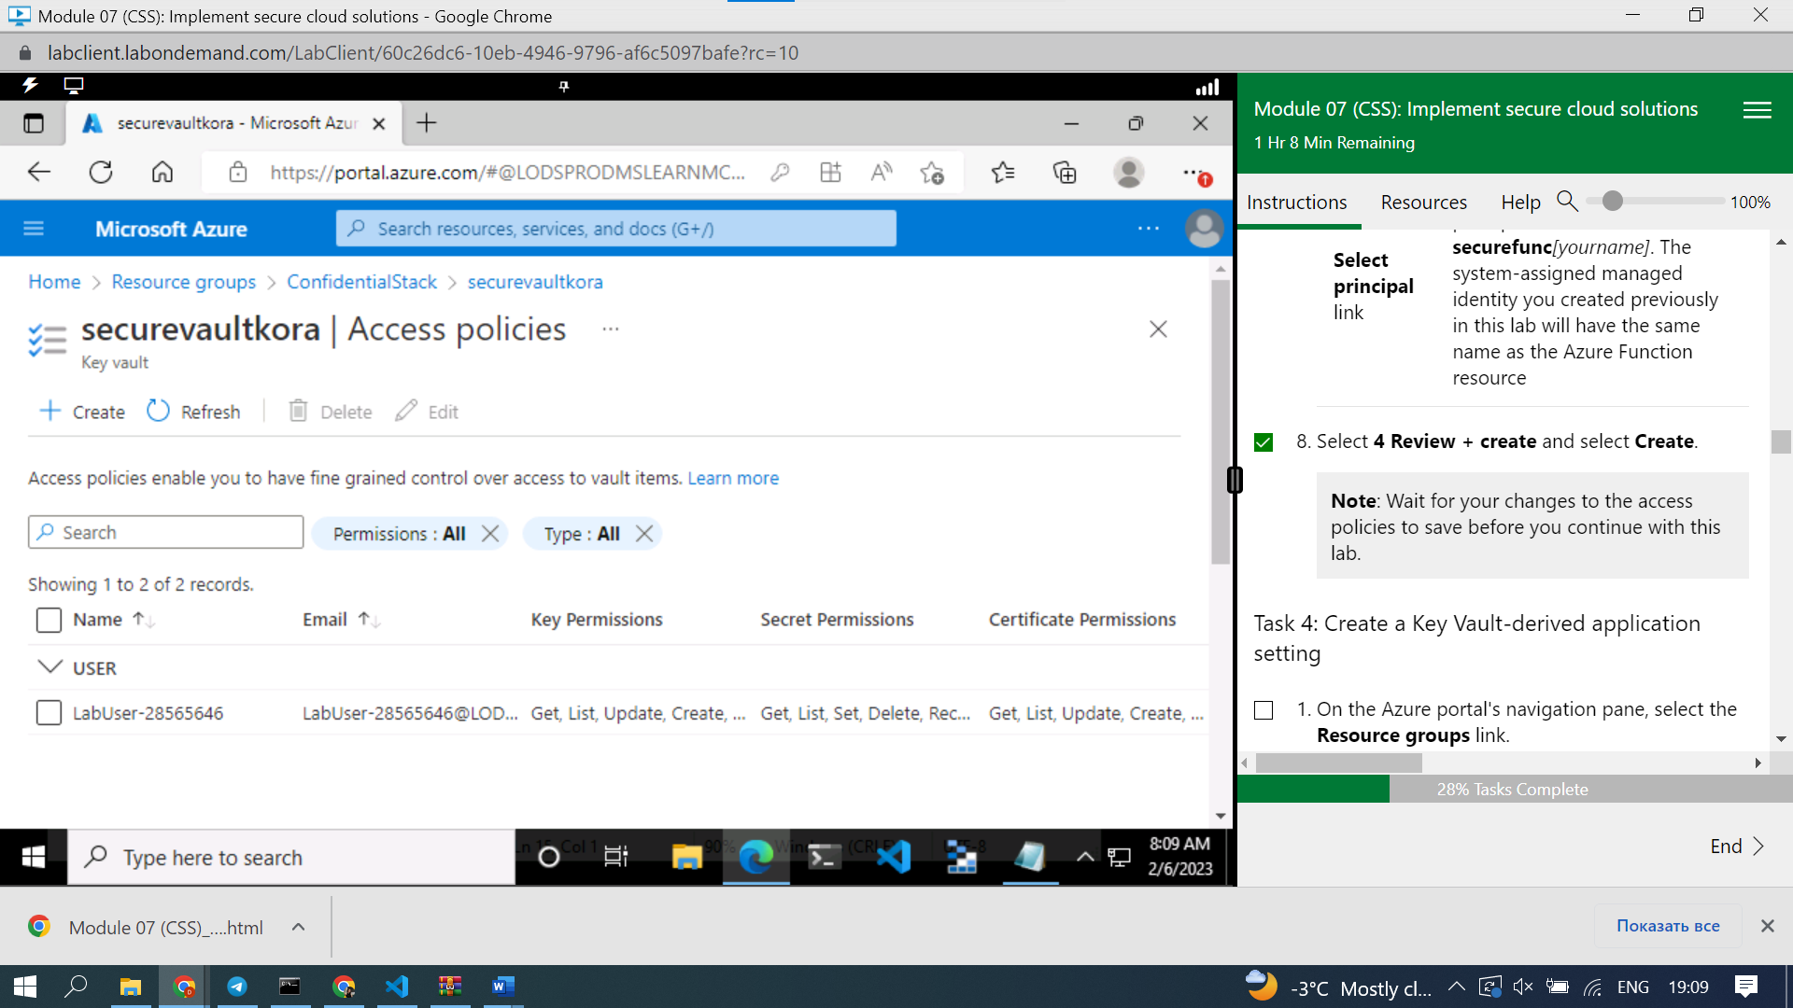

#### **Task 4: Create a Key Vault-derived application setting**

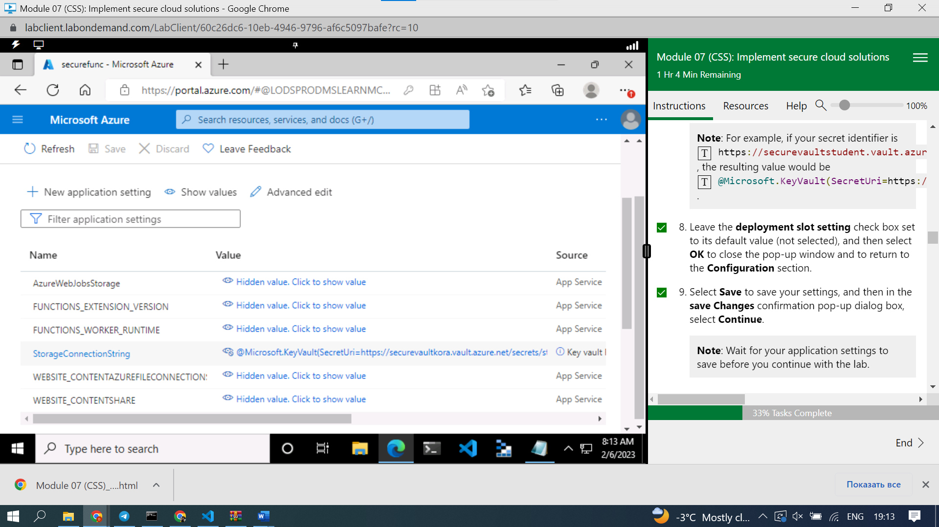

#### **Review**

In this exercise, you created a system-assigned managed service identity for your function app, and then gave that identity the appropriate permissions to get the value of a secret in your key vault. Finally, you created a secret that you referenced within your function app's configuration settings.

### **Exercise 3: Build an Azure Functions app**

#### **Task 1: Initialize a function project**

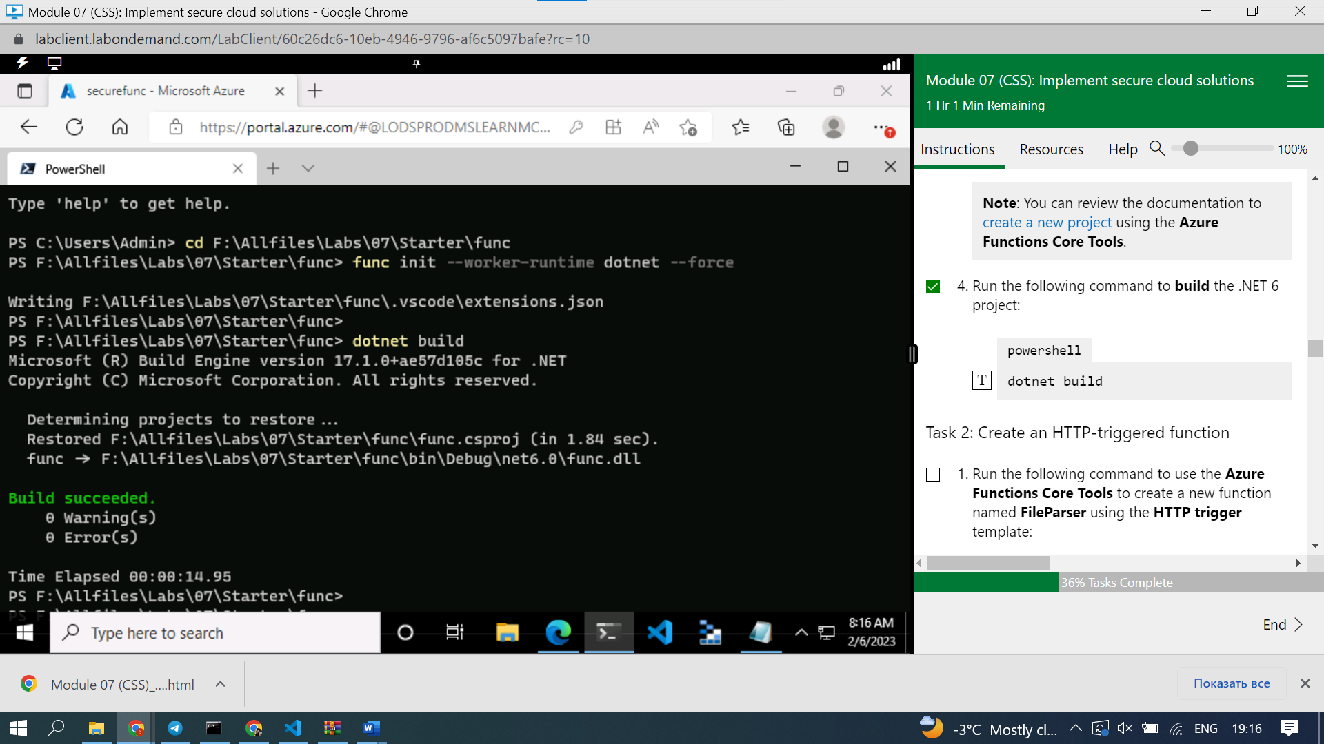

#### **Task 2: Create an HTTP-triggered function**

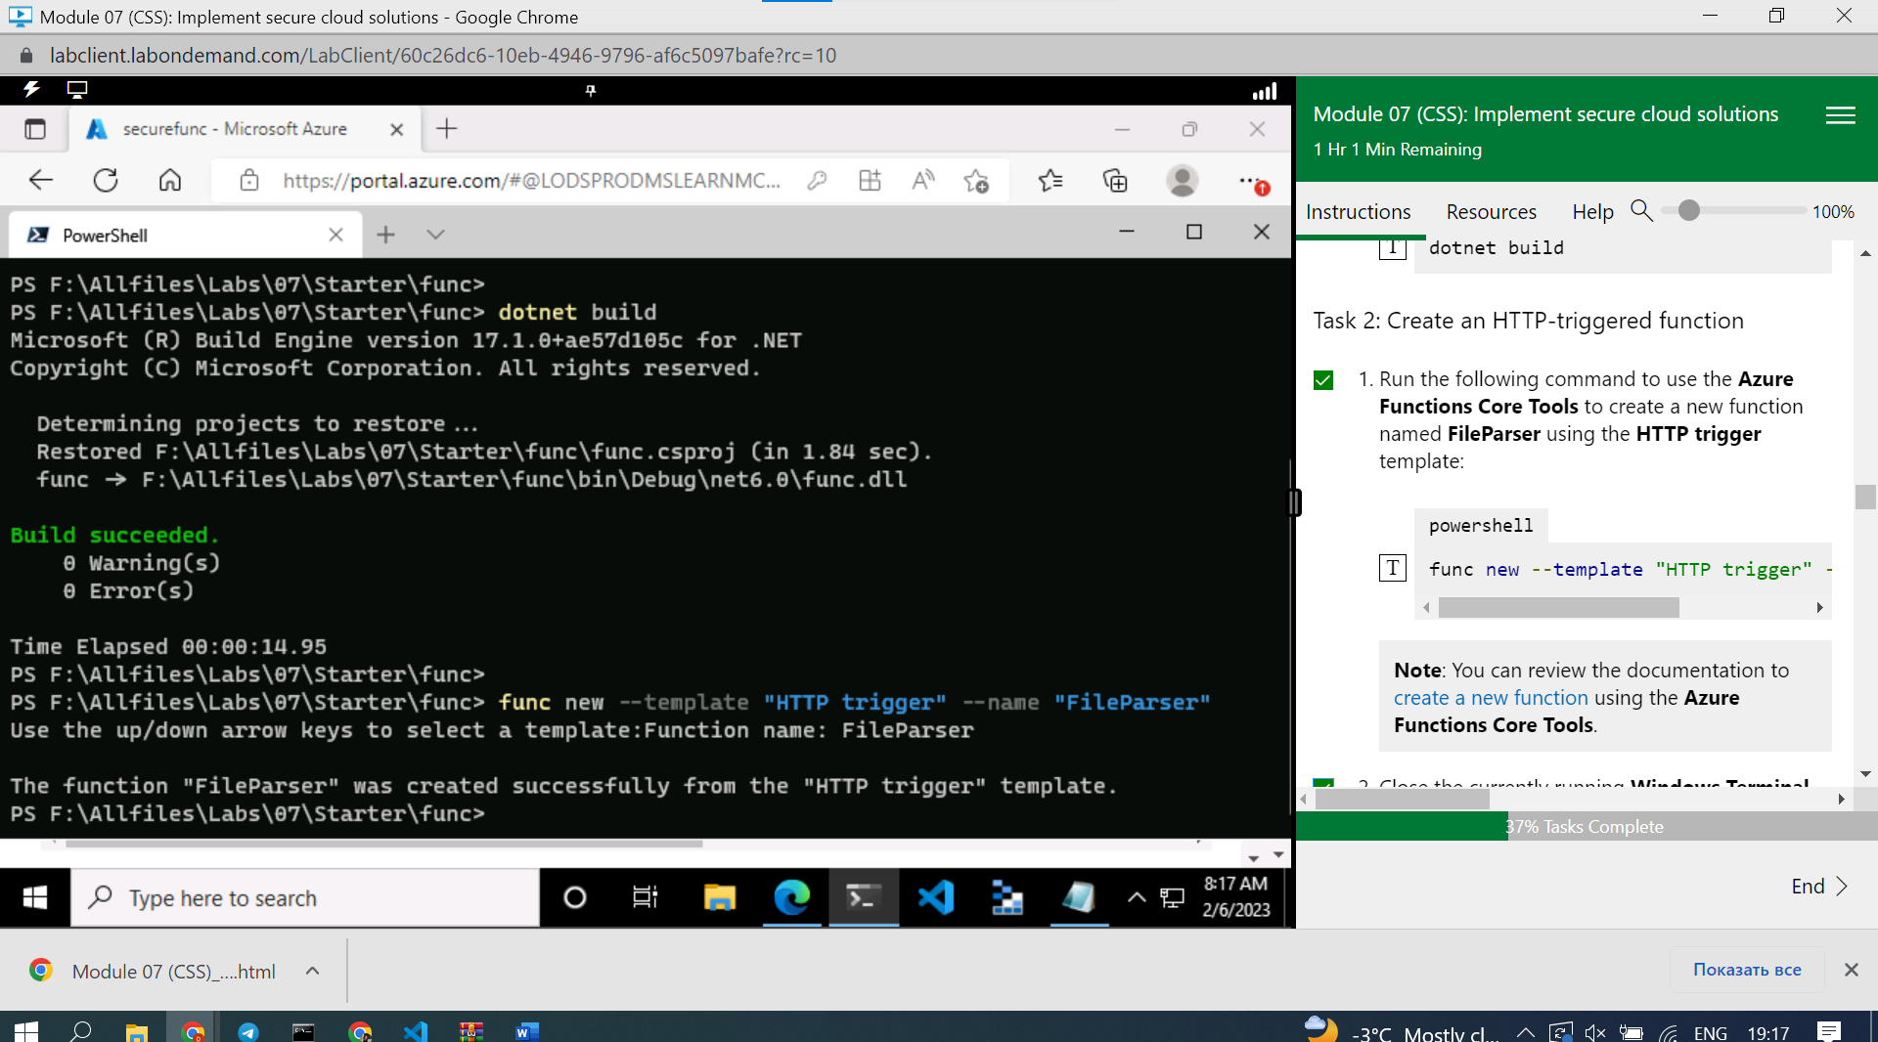

#### **Task 3: Configure and read an application setting**

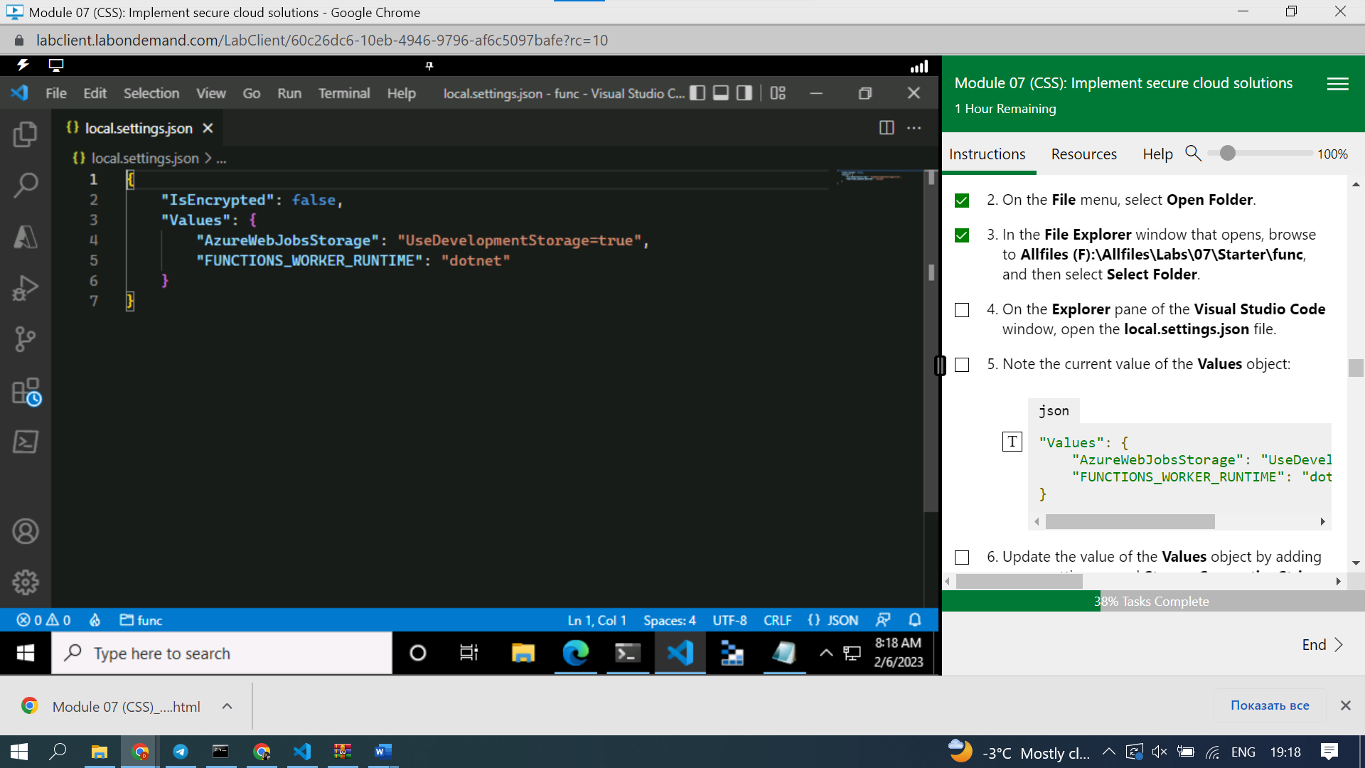

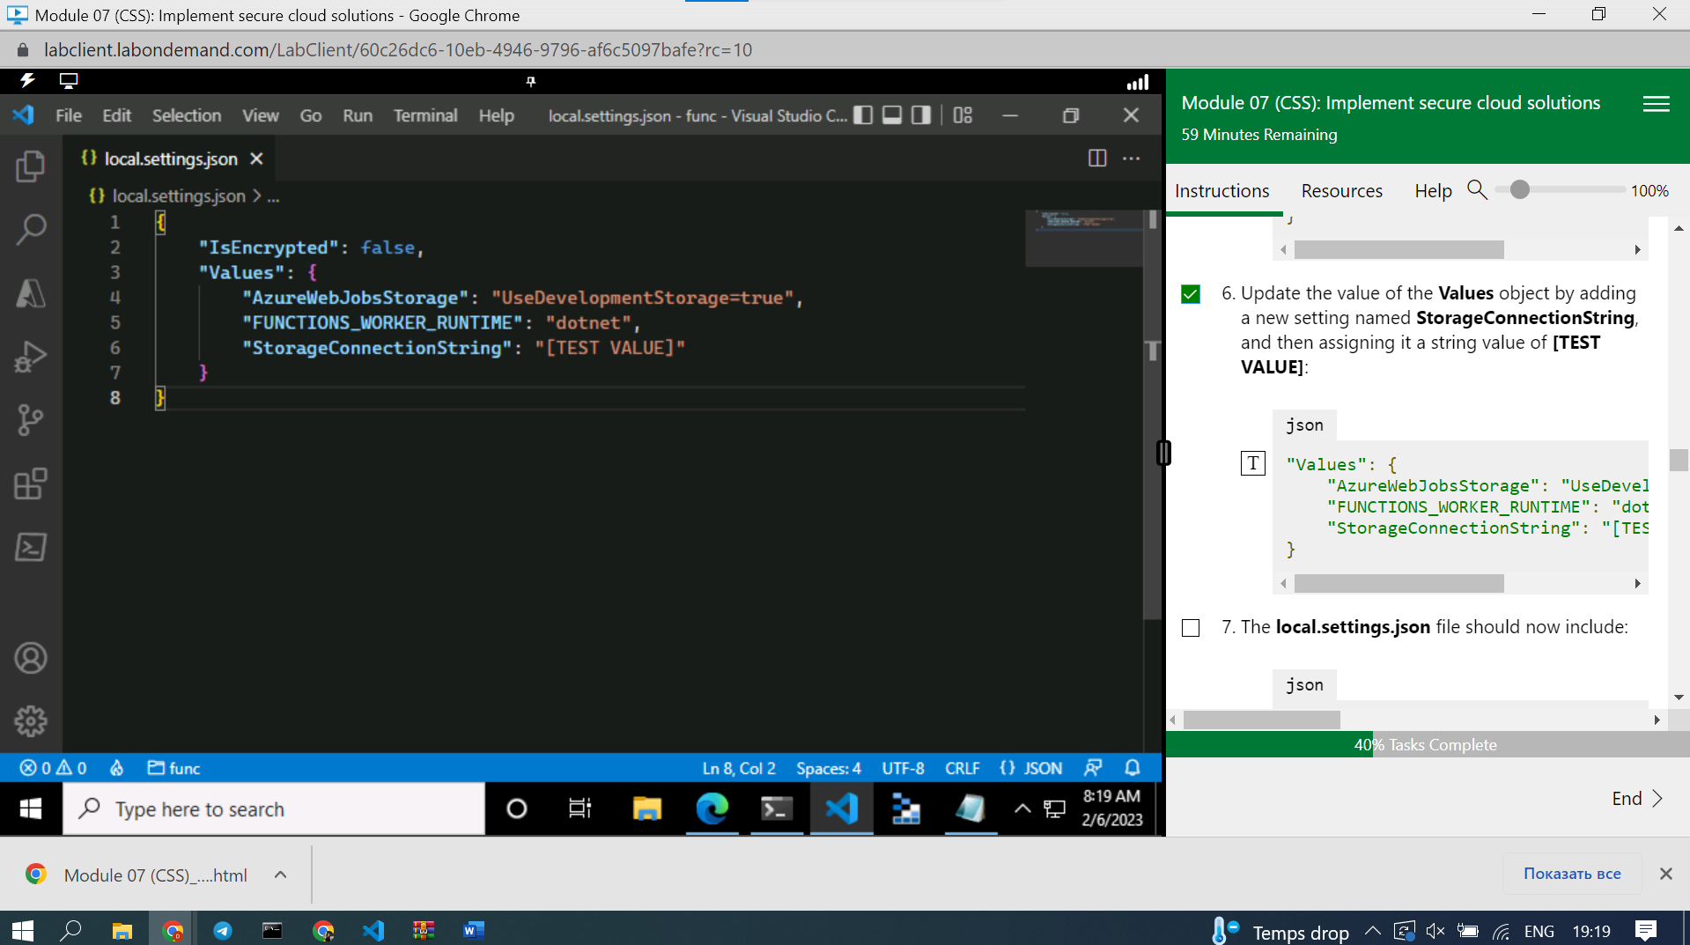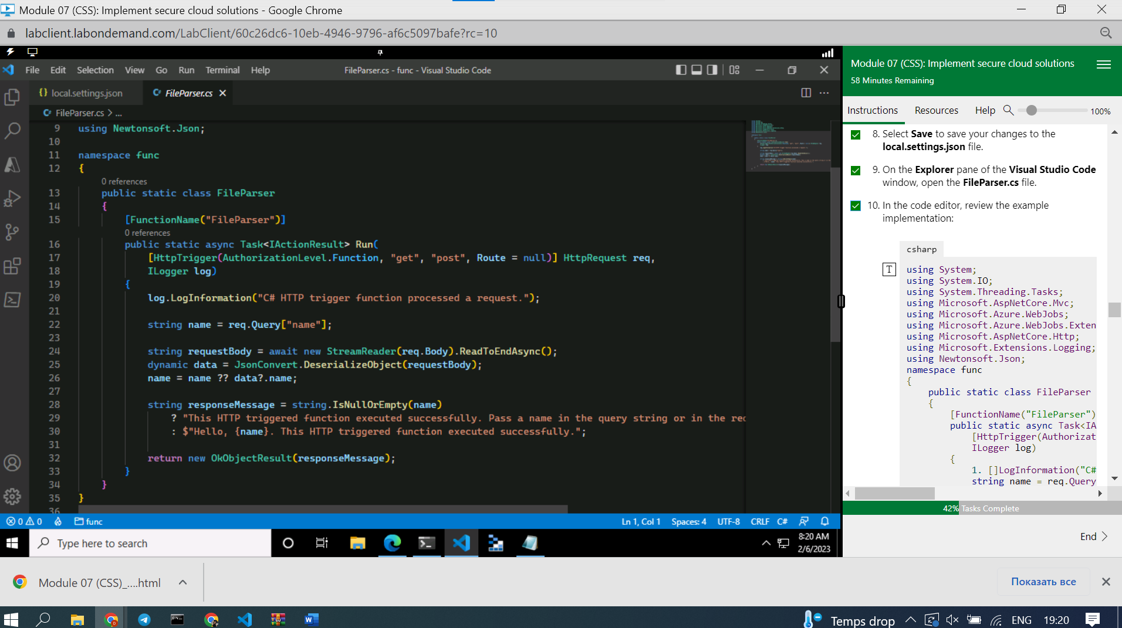

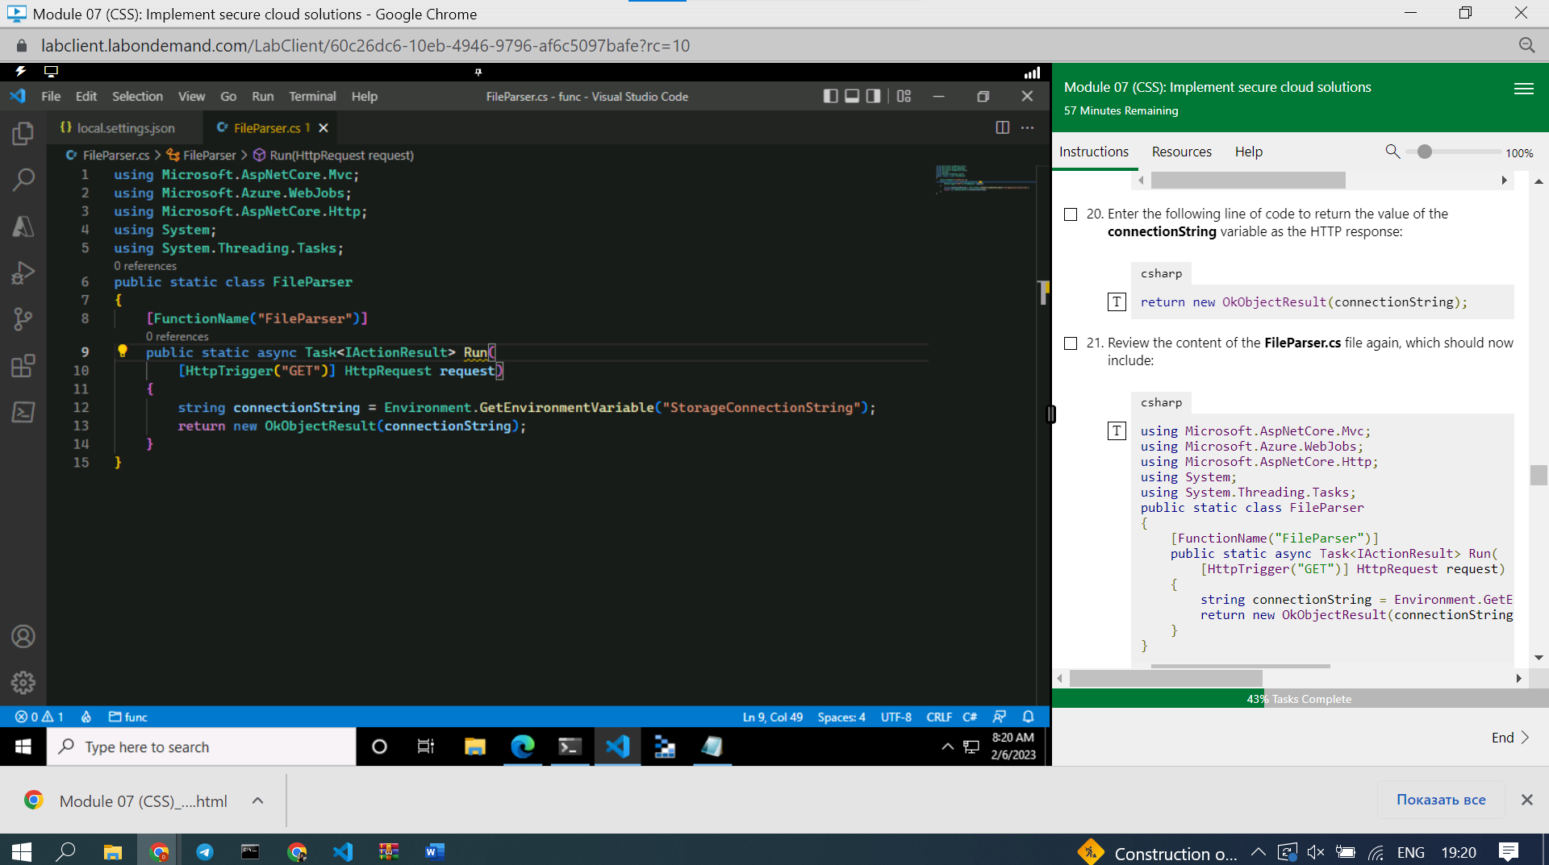

#### **Task 4: Validate the local function**

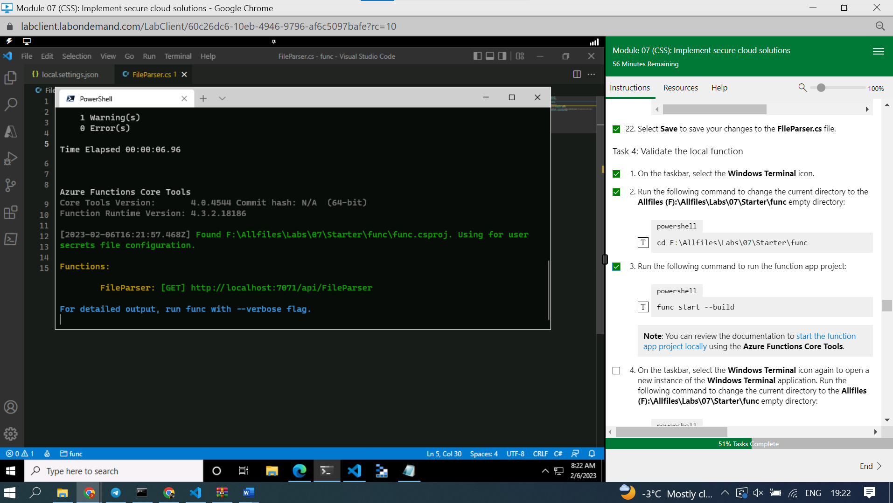

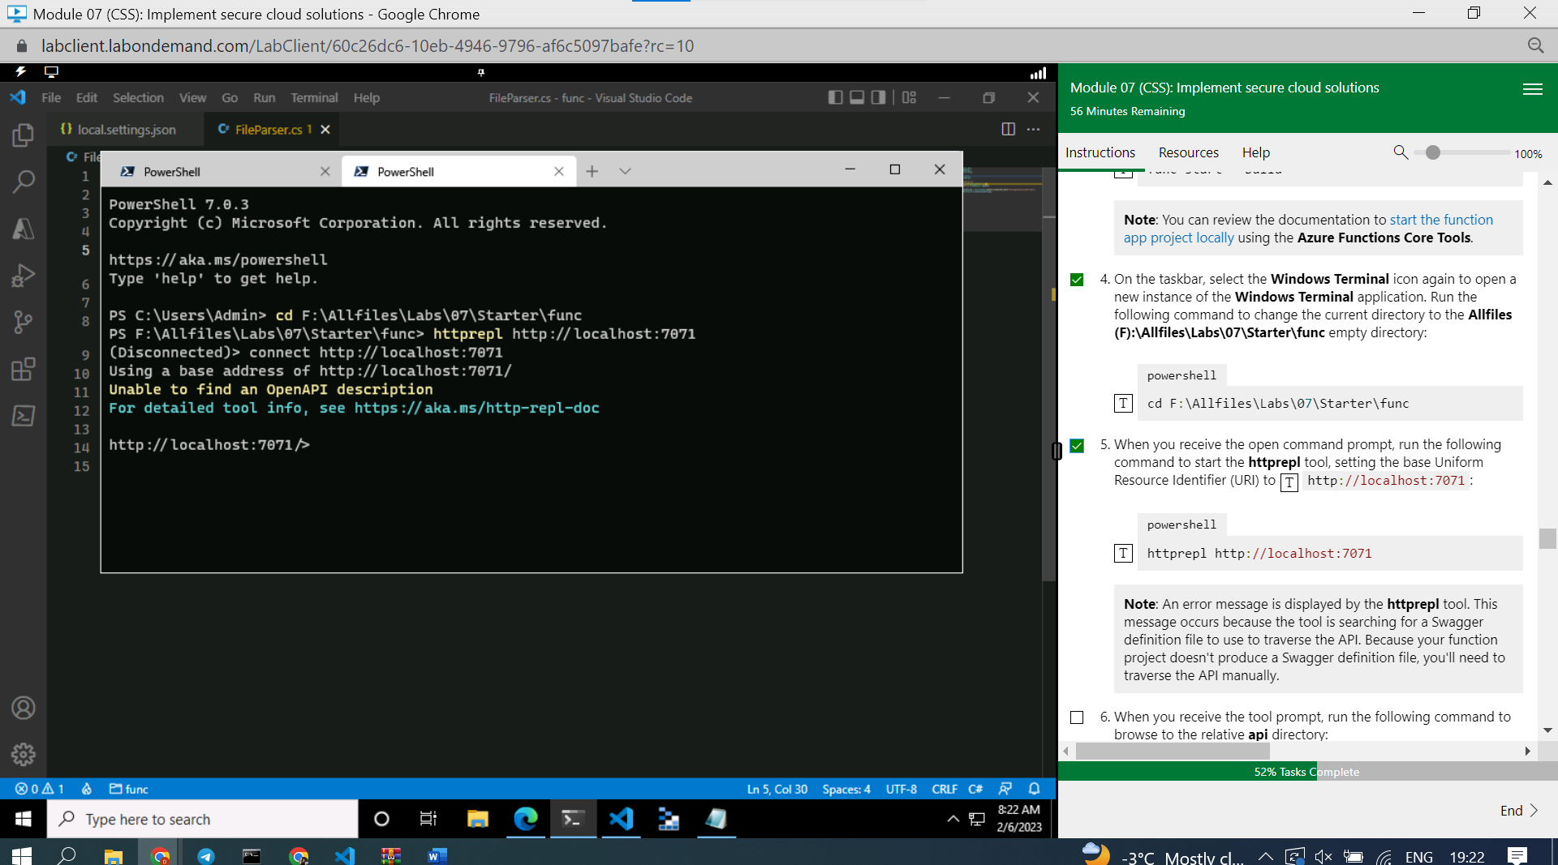

**Note**: An error message is displayed by the **httprepl** tool. This message occurs because the tool is searching for a Swagger definition file to use to traverse the API. Because your function project doesn't produce a Swagger definition file, you'll need to traverse the API manually.

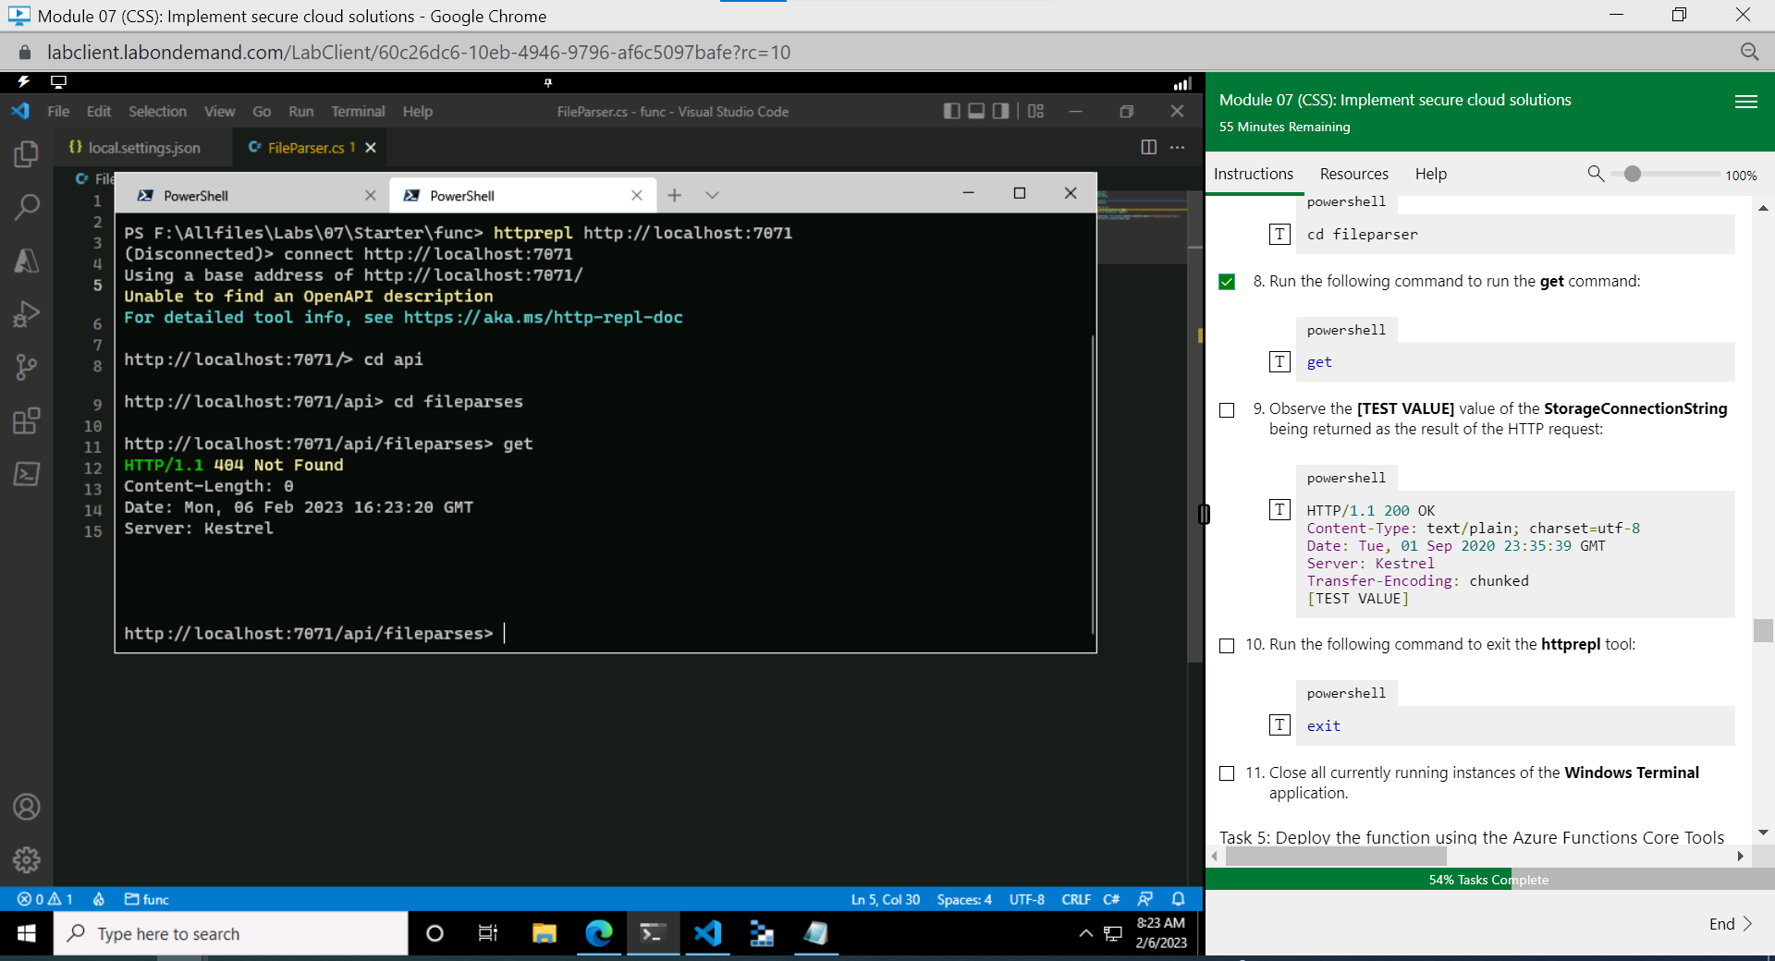

#### **Task 5: Deploy the function using the Azure Functions Core Tools**

Run the following command to publish the function app project

func azure functionapp publish <function-app-name>

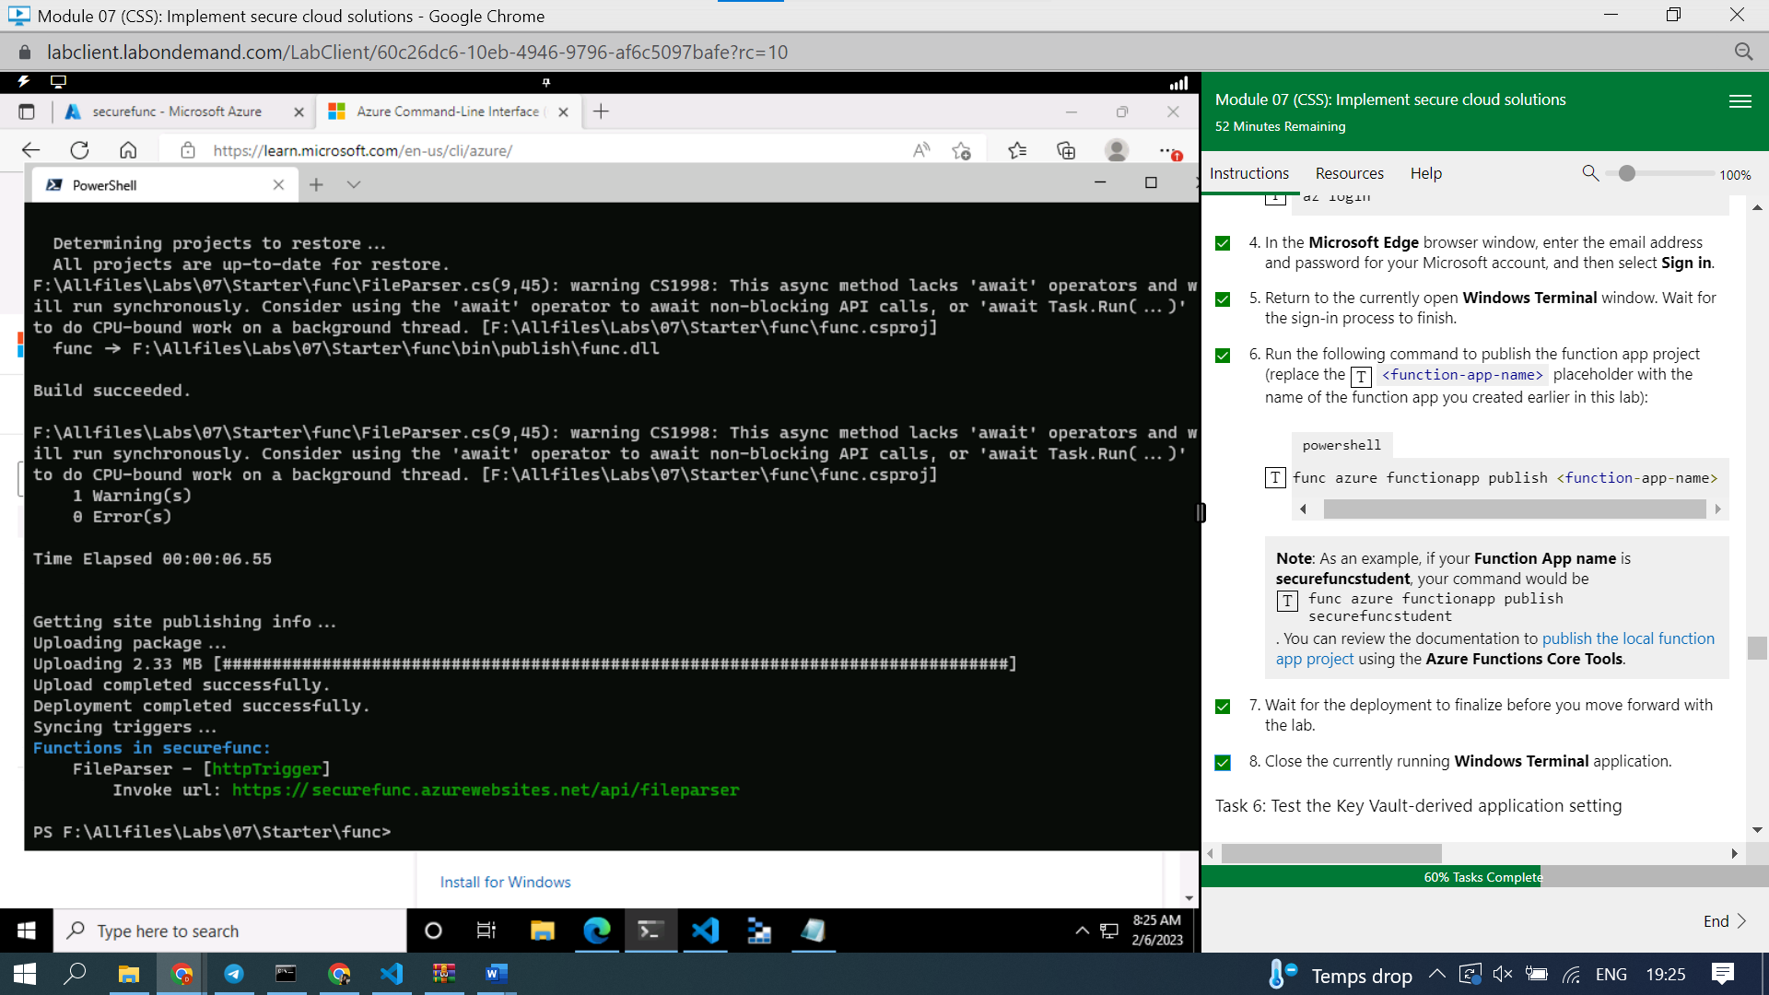

#### **Task 6: Test the Key Vault-derived application setting**

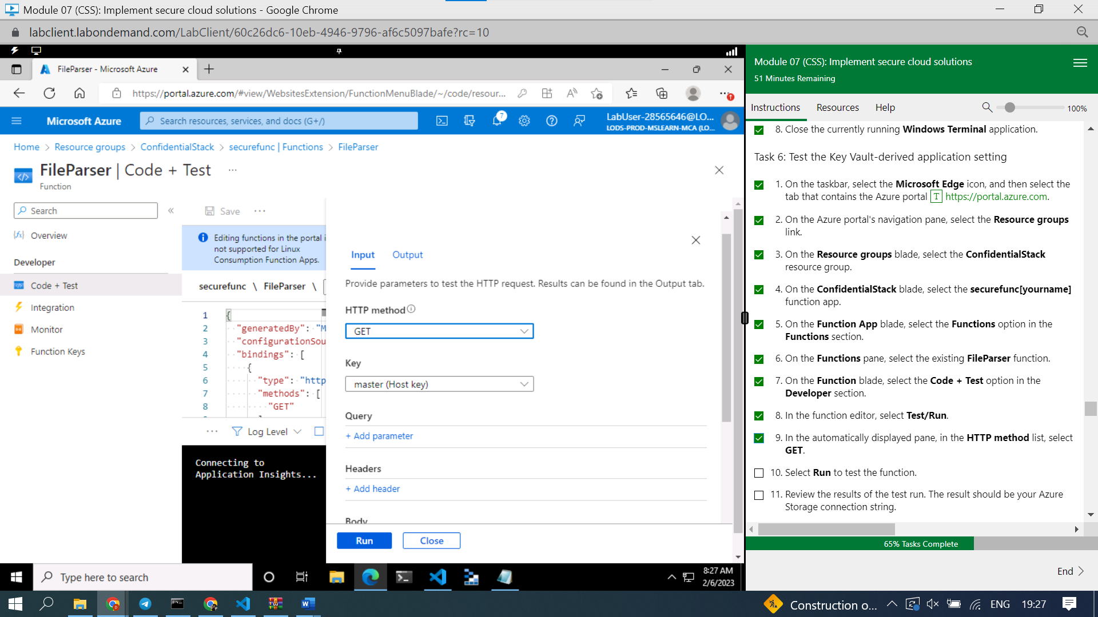

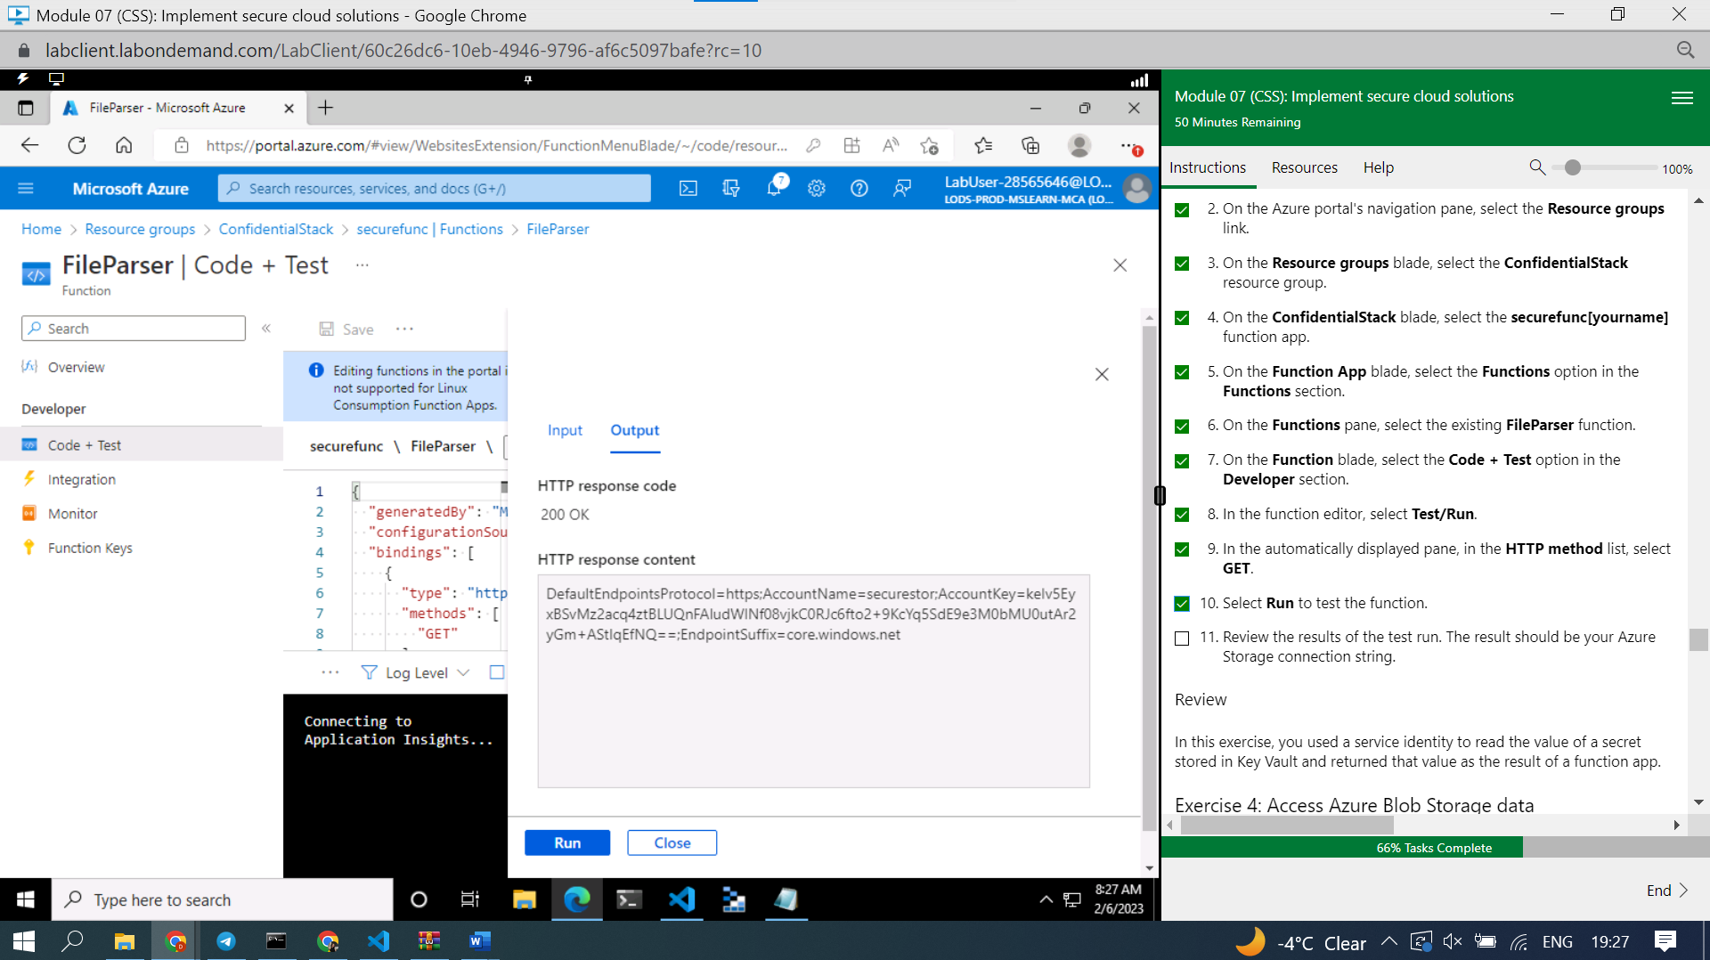

#### **Review**

In this exercise, you used a service identity to read the value of a secret stored in Key Vault and returned that value as the result of a function app.

### **Exercise 4: Access Azure Blob Storage data**

#### **Task 1: Upload a sample storage blob**

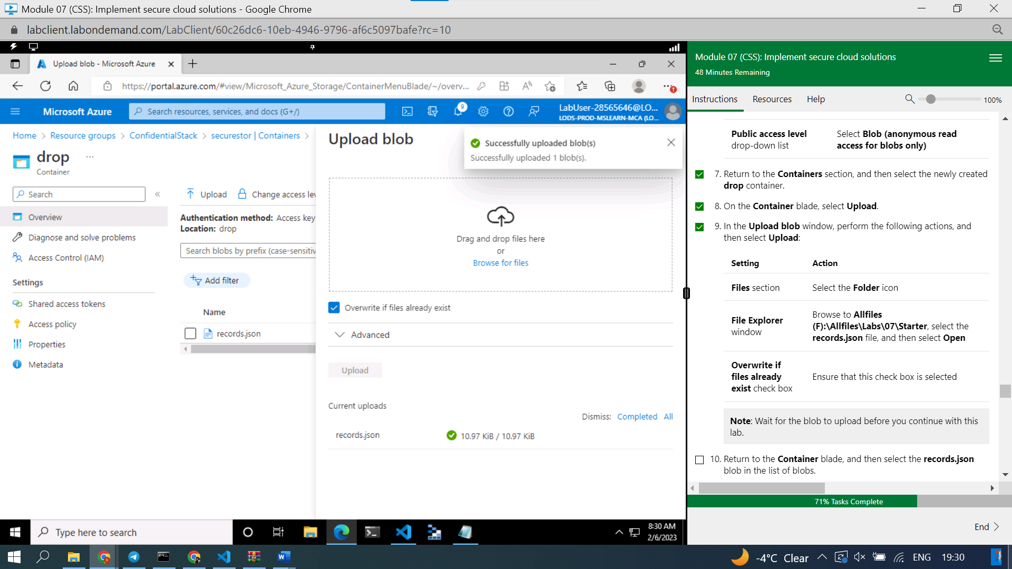

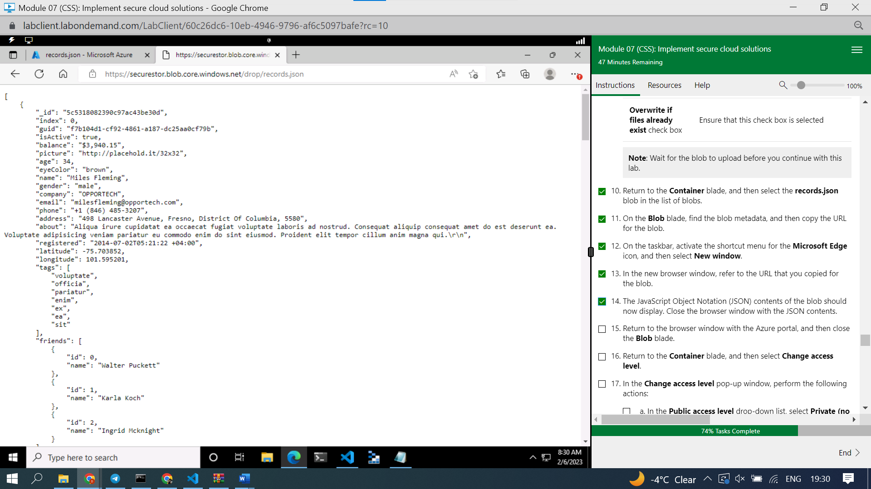

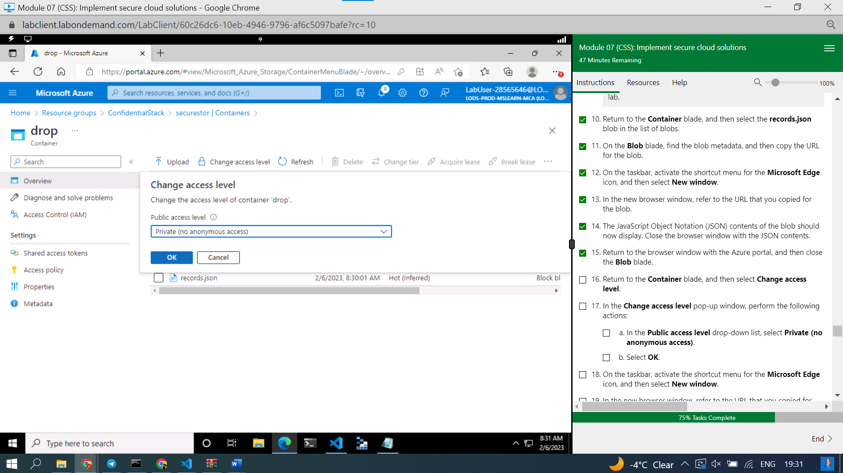

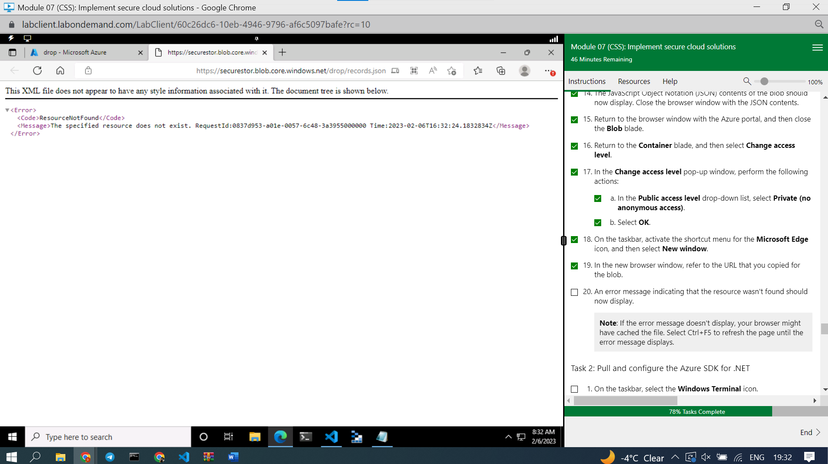

#### **Task 2: Pull and configure the Azure SDK for .NET**

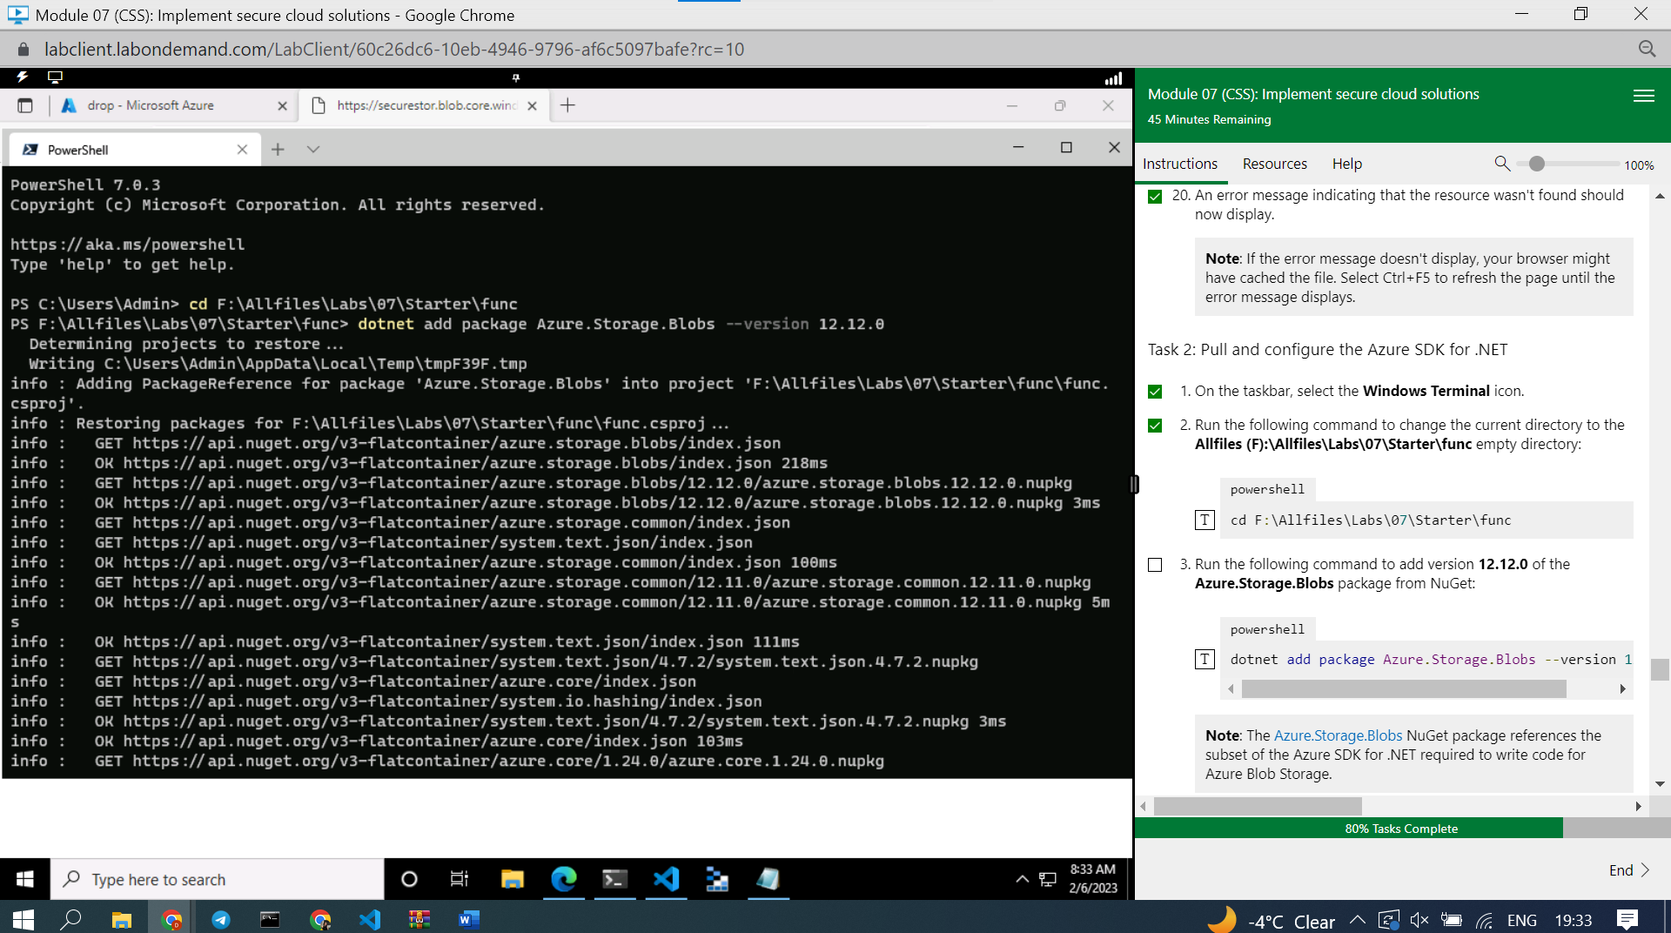

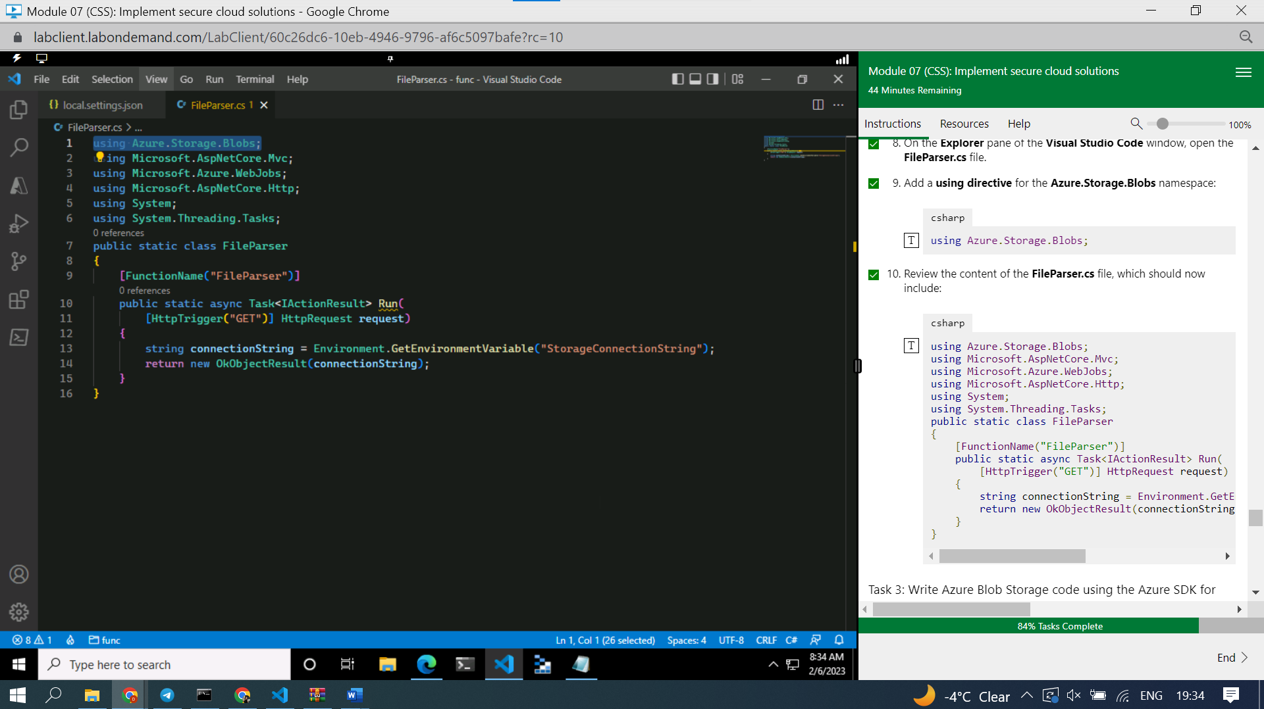

#### **Task 3: Write Azure Blob Storage code using the Azure SDK for .NET**

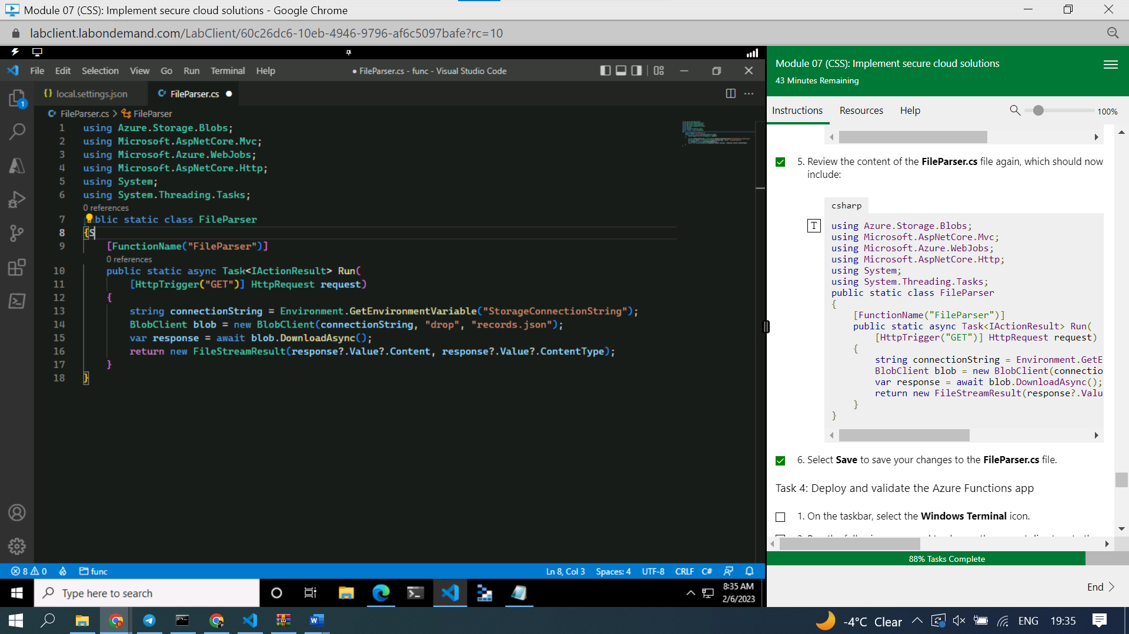

#### **Task 4: Deploy and validate the Azure Functions app**

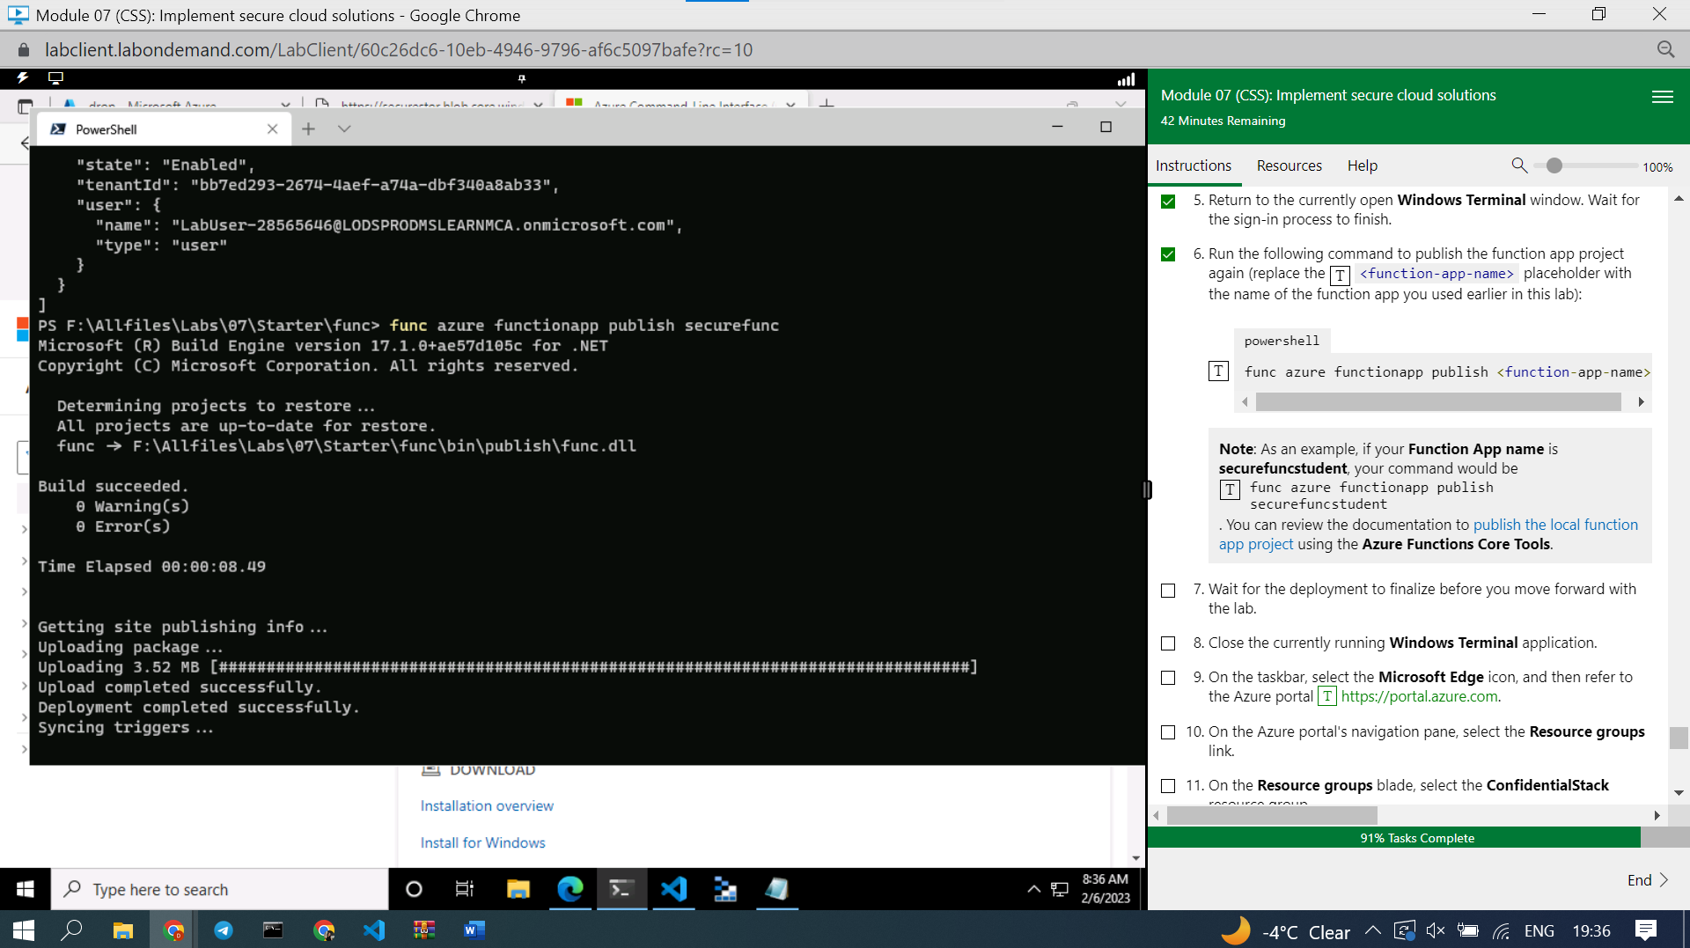

#### **Review**

In this exercise, you used C# code to access a storage account, and then downloaded the contents of a blob.